

|  |
| --- |
| Lindsay Cox |

|  |
| --- |
| Beehive Games |
| Cosmic Assailants |
| Game Concept Document |

Contents

Document History 2

Document Introduction 2

Game Summary 3

Inspiration and Origins 3

Character Personality and Story Ideas and Inspiration 3

Story Ideas 3

Protoganists 4

Antagonists 4

Factions 4

Links for Inspiration 5

# Game Summary

**Project Title:** *Three Thing Game*

**Game Title:** *Cosmic Assailants*

**Players:** *1*

**Genre:** *Space Puzzle Strategy Game*

## Story Synopsis

In the distant future, humanity has reached the outer reaches of space, successfully colonising many planets. Until one day. On the fiery world of Volcanis, the hostile and viscous Volcanites have now declared all out war on the universe, wanting to set fire to every planet in existence. Commander Ace "Gun-Toting" Jupiter is sent on a pre-emptive strike mission to Volcanis with a crack team in order to wipe out the ravenous Volcanites.

## Gameplay Summary

*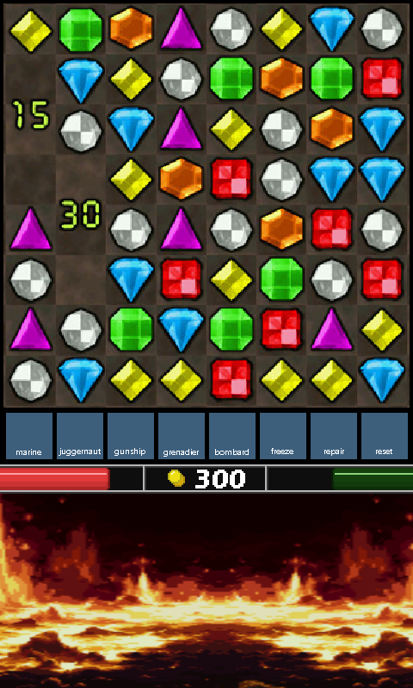Cosmic Assailants* is a puzzle game where players match groups of blocks according to their colour, in order to gain points/energy and create units and use abilities.

The player is presented with a playfield consisting of a virtual grid of squares, each of which can be occupied by a coloured block. Along with this the player is also presented with a battlefield and HP where the battle takes place.

Blocks are stacked on top of one another and rise steadily toward the top of the playfield. The player must arrange blocks in horizontal lines of three or more matching colours by swapping blocks horizontally two at a time. As matching lines are formed, the blocks are cleared from the screen and any blocks above them fall into the gaps.

As the player matches the blocks energy is added. This energy can be spent to spawn units and use commander abilities to combat the enemy Volcanites. When the blocks touch the top of the playfield, energy is depleted until the player removes the blocks.

### Inspiration

Combine the two:

* <http://us.battle.net/sc2/en/game/maps-and-mods/mods/starjeweled>
* <http://en.wikipedia.org/wiki/Tetris_Attack>

# Units

## Human

* **Marine -** ranged unit. Costs 10 energy to spawn, weakest unit.
* **Hydro -** medium-ranged unit. Costs 30 energy to spawn
* **Juggernaught -** Close combat units. Costs 100 energy to spawn, slowest but strongest unit.
* **Gunship -** Air-to-land gunship designed to take out armoured units such as mechs and tanks. Costs 75 energy to spawn

## Volcanites

* **Embers -** Basic Soldiers
* **Pyro -**  flamethrower style units
* **Rock Mech -** Mechs constructed from solidified molten rock
* **Magma Dragon -** fire covered dragon/pterodactly

# Commanders and Abilities

## Ace "Gun-Toting" Jupiter

The fearless, gun-ho commander of the Starship Challenger. He can order tactical strikes from the battleship.

### Commander Abilities

* **Energy Cannon Blast** **-** A large energy blast is sent from the cannon wiping out a large number of enemy units. Costs 120 energy
* **Freeze Bomb -** A bomb that destroys a small number of units and freezes others. Costs 100 energy
* **Repair Nanomachines -** Sends down a repair drone to repair current units. Costs 60 energy

## Firanious

Ruthless leader of the Volcanis who can control fire. Commands units from his Volcano base.

### Commander Abilities

* **Eruption -**  Reigns fireballs down on enemies